Creating a TechZone-based StreamSets Demo Environment

Table of Contents

Introduction 2

Provision a TechZone-based StreamSets Data Plane Instance 2

Choose your deployment method 3

Log in to StreamSets Platform 6

1. If you already have an account on StreamSets Platform 6

2. If you do not yet have an account on StreamSets Platform 6

Deploy a StreamSets Engine 8

1. Clone the Hands On Lab Deployment 8

2. Set Permissions on the Deployment 10

3. Start the Deployment 12

4. Generate an Engine Deployment Script 13

5. Run the Engine Deployment Script 14

6. Confirm the Engine is Healthy 15

Run a Test Pipeline 16

# Introduction

This document describes how to provision and configure a TechZone-based StreamSets Demo Environment.

# Provision a TechZone-based StreamSets Data Plane Instance

Provision an instance of the Data Plane for StreamSets VM in TechZone at this link: <https://techzone.ibm.com/collection/streamsets/environments>

**Dev Data Generator**

Ddd

**Make ID > 0**

dd

**Create account number**

from random import randint

for record in sdc.records:

try:

num_1 = ''.join(["{}".format(randint(0, 9)) for num in range(0, 3)])

num_2 = ''.join(["{}".format(randint(0, 9)) for num in range(0, 7)])

account_number = '000{}-{}'.format(num_1, num_2)

record.value['account_number'] = account_number

sdc.output.write(record)

except Exception as e:

sdc.error.write(record, str(e))

**Generate amount and type**

import random;

for record in sdc.records:

try:

record.value['amount'] = round(random.uniform(1.5, 12000.0),2)

record.value['account_type'] = sdc.state['account_type'][sdc.state['index_1']]

sdc.state['index_1'] = (sdc.state['index_1'] + 1) % len(sdc.state['account_type'])

record.value['type'] = sdc.state['type'][sdc.state['index_2']]

sdc.state['index_2'] = (sdc.state['index_2'] + 1) % len(sdc.state['type'])

sdc.output.write(record)

except Exception as e:

sdc.error.write(record, str(e))

**Add Timestamp**

Output Field:

/timestamp

Field Expression:

${time:extractStringFromDate(time:now(), "yyyy-MM-dd HH:mm:ss")}

**Kafka**

**Generate random order**

ddd

**Generate customer id**

Jyton

from random import randint

# Process records

for record in sdc.records:

try:

num = str(randint(1, 10000))

customer_id = '000{}'.format(num)

record.value['customer_id'] = customer_id

sdc.output.write(record)

except Exception as e:

# Send record to error handling

sdc.error.write(record, str(e))

**Generate amount and payment**

Jyton

import random

# Mapping payment type

payment_type_map = {

1: 'voucher',

2: 'credit_card',

3: 'boleto'

}

# Process records

for record in sdc.records:

try:

record.value['payment_amount'] = round(random.uniform(50, 100000.0), 2)

record.value['payment_type'] = payment_type_map[random.randint(1, 3)]

sdc.output.write(record)

except Exception as e:

# Send record to error handling

sdc.error.write(record, str(e))

**Add timestamp**

Output Field:

/purchase_datetime

Field Expression:

${time:extractStringFromDate(time:now(), "yyyy-MM-dd HH:mm:ss")}

**Transaction records**

Order

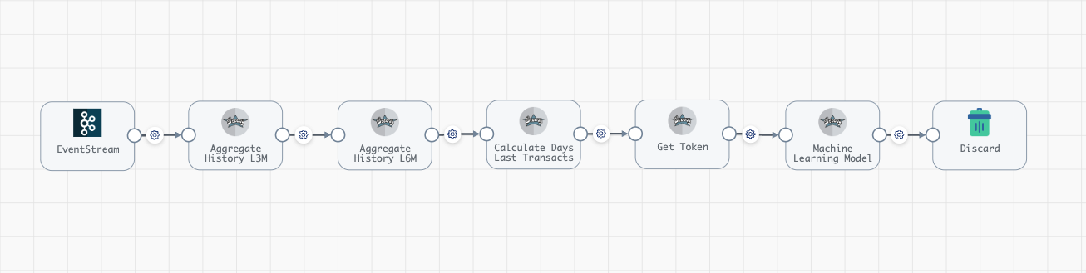

ddd

ddd

ddd

ddd

ddd

ddd

ddd

ddd

ddd

ddd

ddd